A Project Synopsis

Of

**Shop Account Analysis**

submitted in partial fulfilment of the requirements

for the award of the degree of

**Bachelor of Technology**

**Computer Science & Engineering**

By

Aman Pathak (191599002)

Under the guidance of

**Mr. Vinay Agarwal**

Department of Computer Engineering & Applications

Institute of Engineering & Technology



GLA UNIVERSITY

Mathura – 281406, India

**Feb, 2021**



**Department of computer Engineering and Applications**

**GLA University, Mathura**

**17 km. Stone NH#2, Mathura-Delhi Road, P.O. – Chaumuha,**

**Mathura – 281406**

# DECLARATION

I hereby declare that the work which will be presented in the B.Tech. Project “**Shop Account Analysis**” in partial fulfilment of the requirements for the award of the Bachelor of Technology in Computer Science & Engineering of GLA University, Mathura, will be authentic record of our own work to be carried out under the supervision of **Mr. Vinay Agarwal**, Assistant Professor, Institute of Engineering & Technology.

The contents of this project Synopsis, in full or in parts, have not been submitted to any other Institute or University for the award of any degree.

**Sign** ______________________

**Name :** Aman Pathak

**University Roll No.:** 191599002

**Date:**



**Department of computer Engineering and Applications**

**GLA University, Mathura**

**17 km. Stone NH#2, Mathura-Delhi Road, P.O. – Chaumuha,**

**Mathura – 281406**

# CERTIFICATE

This is to certify that the above statements made by the candidate are correct and true to the best of my knowledge and belief.

_______________________

**Supervisor**

Mr.Vinay Agarwal

Assistant Professor

Institute of Engineering & Technology

GLA University

# Problem Statement

The purpose of the project entitled as “Shop Account Analysis” is to compute the Office Management of Shops to develop software which is user friendly, fast, and cost – effective. It deals with the collection of Products or items information, diagnosis details, etc. Traditionally, it was done manually. The main function of the system is register and store product details and customer reviews and retrieve these details as and when required, and also to manipulate these details meaningfully. The Shop Account System can be entered using a username and password. It is accessible either by an administrator or owner. Only they can add data into the database. The data can be retrieved easily. The data are well protected for personal use and makes the data processing very fast.

**Objective**

The project objective is to deliver the online facility application into our own platform.It is the process whereby consumers directly buy goods or services from a seller in real-time, without an intermediary service, over the Internet. It is a form of electronic commerce .

**Feasibility Study**

The feasibility of the project is analysed in this phase and business proposal is put forth with a very general plan for the project and some cost estimates. During system analysis the feasibility study of the proposed system is to be carried out

**Economic feasibility**

This study is carried out to check the economic impact will have on the system will have on the organization. The amount of fund that the company can pour into the research and development of the system is limited. The expenditures must be justified.

**Technical feasibility**

This study is carried out to check the technical feasibility, that is,the technical requirements of the system. Any system developed must not have a high demand on the available available technical resources.

**Operational feasibility**

The aspect of study is to check the level of acceptance of the system by the user. This includes the process of training the user to use the system efficiently. The user must not feel threatened by the system, instead must accept it as a necessity.

**SYSTEM DESIGN**

**State chart Diagram:**

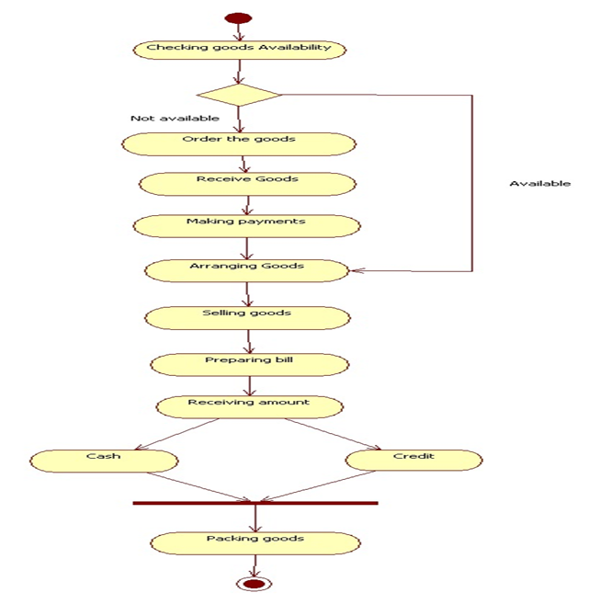

**INTRODUCTION TO UML:**

**UML Design**

The Unified Modeling Language (UML) is a standard language for specifying, visualizing, constructing, and documenting the software system and its components. It is a graphical language , which provides a vocabulary and set of semantics and rules. The UML focuses on the conceptual and physical representation of the system. It captures the decisions and understandings about systems that must be constructed. It is used to understand, design, configure, maintain, and control information about the systems.

The UML is a language for:

⦁ Visualizing

⦁ Specifying

⦁ Constructing

⦁ Documenting

**Visualizing:-**

Through UML we see or visualize an existing system and ultimately we visualize how the system is going to be after implementation. Unless we think, we cannot implement. UML helps to visualize, how the components of the system communicate and interact with each other.

**Specifying:-**

Specifying means building, models that are precise, unambiguous and complete UML addresses the specification of all the important analysis design, implementation decisions that must be made in developing and deploying a software system.

**Constructing:-**

UML models can be directly connected to a variety of programming language through mapping a model from UML to a programming language like Python. Forward Engineering and Reverse Engineering is possible through UML

**Documenting**

The Deliverables of a project apart from coding are some Artifacts, which are critical in controlling, measuring and communicating about a system during its developing requirements, architecture, desire, source code, project plans, tests, prototypes releasers, etc...

**Methodology**

**Front End:**

**WHY HTML:**

HTML defines the structure and layout of a Web document by using a variety of tags and attributes. The correct structure for an HTML document starts with **<HTML><HEAD>**(enter here what document is about)**<BODY>** and ends with **</BODY></HTML>**. All the information you'd like to include in your Web page fits in between the **<BODY>** and **</BODY>** tags.

**WHY CSS:**

Cascading style sheets are used to format the layout of Web pages. They can be used to define text styles, table sizes, and other aspects of Web pages that previously could only be defined in a page's HTML.

CSS helps Web developers create a uniform look across several pages of a Web site. Instead of defining the style of each table and each block of text within a page's HTML, commonly used styles need to be defined only once in a CSS document. Once the style is defined in cascading style sheet, it can be used by any page that references the CSS file. Plus, CSS makes it easy to change styles across several pages at once. For example, a Web developer may want increase the default text size from 10pt to 12pt for fifty pages of a Web site. If the pages all reference the same style sheet, the text size only needs to be changed on the style sheet and all the pages will show the larger text.to

.

**Back End:**

**Python:**

Python is an interpreted, object-oriented programming language similar to PERL, that has gained popularity because of its clear syntax and readability. Python is said to be relatively easy to learn and portable, meaning its statements can be interpreted in a number of operating systems, including UNIX-based systems, Mac OS, MS-DOS, OS/2, and various versions of Microsoft Windows 98. Python was created by Guido van Rossum, a former resident of the Netherlands, whose favorite comedy group at the time was Monty Python's Flying Circus. The source code is freely available and open for modification and reuse. Python has a significant number of users.

**Django:**

With Django, you can take Web applications from concept to launch in a matter of hours. Django takes care of much of the hassle of Web development, so you can focus on writing your app without needing to reinvent the wheel. It’s free and open source.

Django helps developers avoid many common security mistakes by providing a framework that has been engineered to "do the right things" to protect the website automatically. For example, Django provides a secure way to manage user accounts and passwords, avoiding common mistakes like putting session information in cookies where it is vulnerable (instead cookies just contain a key, and the actual data is stored in the database) or directly storing passwords rather than a password hash.

**Technologies to be used**

**Hardware**

* **Operating Systems:** Windows 7 or later
* **Processor**: Intel i3 or later
* **Ram**: 2Gb or more
* **Disk Space:** 2 Gb

**Software**

* Python
* HTML,CSS Language
* Django.

**Conclusion**

Through the development of Shop account Analysis on E-Commerce platform, we get a clear understanding of overall process of the website. The core part of the Shop Account Analysis is mainly composed of main interface, cart, menus, profile searching product. .

This project will help us to understand the basics as well as some advanced concepts of E-Commerce website